**VISUALIZATION USING MATPLOTLIB WITH DIFFERENT TYPES OF PLOTS**

Why data visualization?

* **Human brain can process information easily when it is in pictorial or graphical form.**

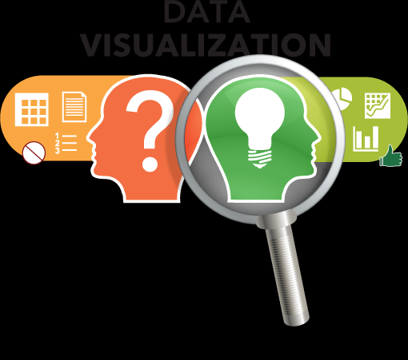

Example to data visualization:

A person working as an analyst , he need to show the analyst to his boss or CEO whatever, now they understand it by on just extra sheet numbers but another person is not an analyst he is not a technical sounder but a person who analyst is technical sounder what will he do to understand the person who doesn’t a technical sounder he do it by representing graphically . It well known fact

“Human brain can process information easily when it is in pictorial or graphical form”.

* **Data visualization allows us to quickly interpret the data and adjust different variables to see their effect**.



Data visualization allows us to quickly interpret the data by representing graphically.

Now basically alouds quickly interpret the data just by looking at the graph it refer to know what the data is about and what is the trend . If you have not analytic background you take extra sheet to understand . So it is there in the graph form to easily understand and now what is change in certain variable in c what will be the output by using graphical representation of data that will give very good idea is to what are variable useful to us and also what are the variables are not useful to us in analysis in order to form an experiment and efficient quick way in data visualization.

* **Data visualization is the presentation of data in a pictorial and graphical format.**

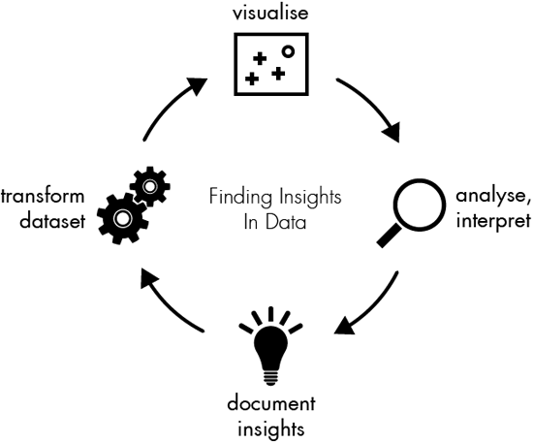

First we should know what are the useful from data visualization.

* We can use to identify the area that need attention or proper organization.
* It can also used in order to clarify to factor implements customer behaviour. It may depends on season or anything else.

Example: You couldn’t buy shwether at summer time. Where you selling the product whom you selling the product is very important in data visualization.

**Data Visualization place very important role and it is a major application of data visualization.**

1. **Visualize :-** Basically we understand what the data visualize in form of graph and we understand what the data actually talking about,

Now taking an example we have data tells about youth percentage of unemployed youth country wise from 2010 to 2014 and we have data the visualize . The moment we visualize it we will get know that these country doesnot have any unemployee ratio and these country have low number unemployee percentage and some countries have large number percentage of unemployee. According to this we just graph easily when visualize , after that you make certain that analyse.

1. **Analyse** :- We take same example , if we find any changes in the percentage in the unemployment in between 2010 to 2014 and I analyse that afterward document insight.
2. **Document insight** :- After the analyse what the output will come now see what are countries doing good the percentage of youth have gone and which country got down what the country table there is no change . So we see that make document .
3. **Transform Dataset** :- After that we transform or data set by certain these data that we don’t need so what we do we transform that data set remove these things or they might be certain that we need which is not there so we ask piece according we transfer our data one we have done that we start visualize in order to understand our data.

**MATPLOTLIB**

What is Matplotlib?

Matplotlib is a Python package use for 2D graphics.

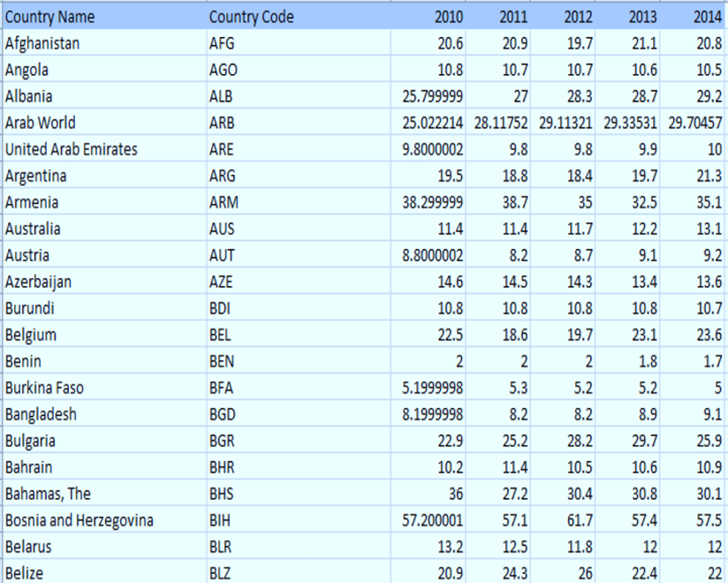

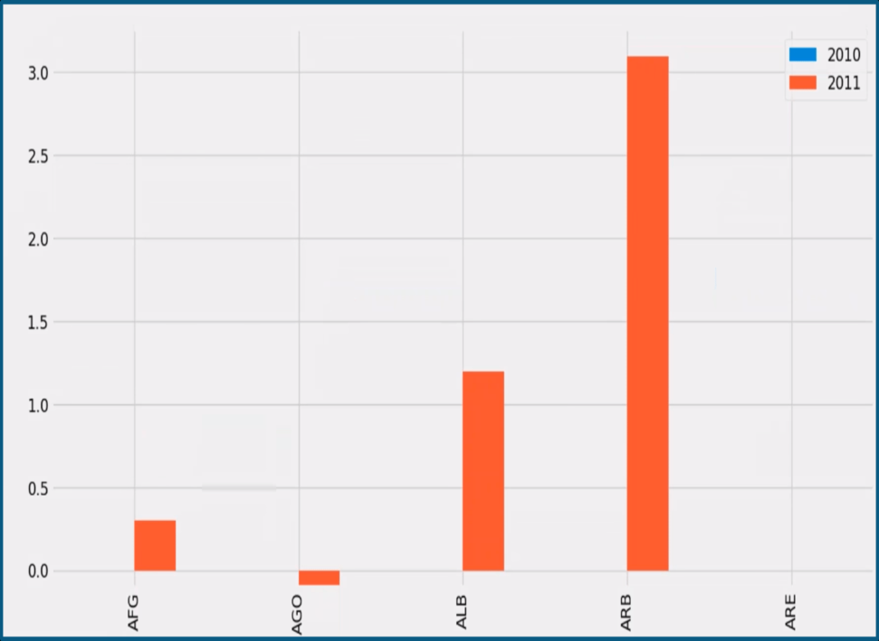

Now it is very important to understand matplotlib fundamentally.

It is basics we have some data then our computer will draw the data like graph which stored in the computer memory. The computer store in that data in show that data .These the computer drawing the thing then perform tasks show on screen. It is very important to understand

that how matplotlib fundamentally. You have example in front of screen. The country name with unemployee percentage. I have done in between 2010 to 2014 plot.These plot called as **Bar graph.**

Now we look at the types of plots

**Types of Plots**

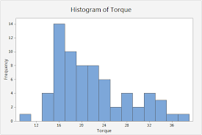

**Bar Graph**  **Histograms**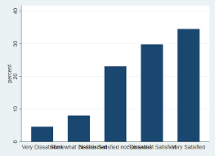

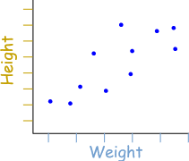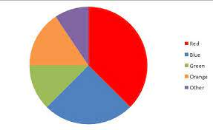

**Scatter Plot**  **Pie Plot**

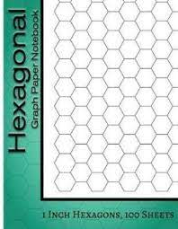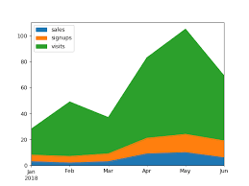

**Hexgonal Bin Plot** **Area Plot**

**Plotting Graph with using code**

* from matplotlib import pyplot as plt

x=[5,8,10]

y=[12,16,6]

plt.plot(x,y)

plt.title('info')

plt.ylabel('y axis')

plt.xlabel('x axis')

plt.show()

**output:**

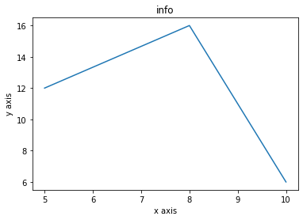

* from matplotlib import pyplot as plt

from matplotlib import style

style.use("ggplot")

x=[5,8,10]

y=[12,16,6]

x2=[6,9,11]

y2=[6,15,7]

plt.plot(x,y,'g',label='line1',linewidth=5)

plt.plot(x2,y2,'c',label='line2',linewidth=5)

plt.title('info')

plt.ylabel('y axis')

plt.xlabel('x axis')

plt.legend()

plt.grid(True,color='k')

plt.sh ow()

**output:**

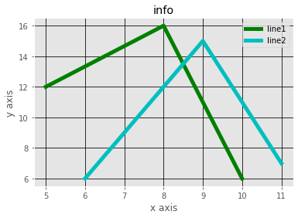

**Bar Graph**

* import matplotlib.pyplot as pltplt.bar([1,3,5,7,9],[5,2,7,8,2],label='example1')

plt.bar([2,4,6,8,10],[8,6,2,5,6],label='example2',color='g')

plt.legend()

plt.xlabel('bar no')

plt.ylabel('bar height')

plt.title('Bar graph')

plt.show()

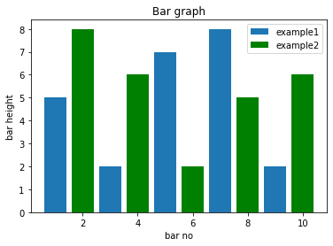 **output:**

* import matplotlib.pyplot as plt

plt.barh([1,3,5,7,9],[5,2,7,8,2],label='example1')

plt.barh([2,4,6,8,10],[8,6,2,5,6],label='example2',color='g')

plt.legend()

plt.xlabel('bar no')

plt.ylabel('bar height')

plt.title('Bar graph')

plt.show()

**Output:**

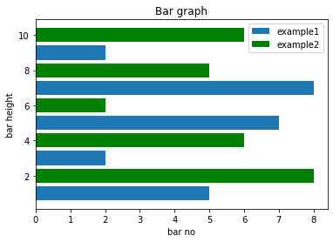

**Histogarm**

* import matplotlib.pyplot as plt

# frequencies

ages = [2, 5, 70, 40, 30, 45, 50, 45, 43, 40, 44,

60, 7, 13, 57, 18, 90, 77, 32, 21, 20, 40]

range = (0, 100)

bins = 20

# histtype : {'bar', 'barstacked', 'step', 'stepfilled'}, optional

plt.hist(ages, bins, range, color='blue',

histtype='bar', rwidth=0.5)

plt.xlabel('age')

plt.ylabel('No. of people')

plt.title('Ages of people')

plt.show()

**Output:**

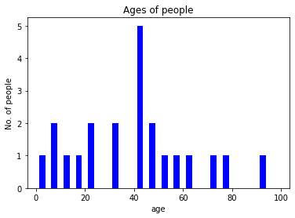

* import matplotlib.pyplot as plt

import numpy as np

y=np.linspace(0,10,100)

plt.plot(y,np.sin(y))

plt.plot(y,np.cos(y))

plt.show()

**Output:**

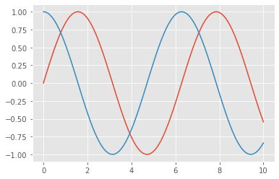

**Scatter Plot**

* import matplotlib.pyplot as plt

x = [1,2,3,4,5,6,7,8]

y = [5,2,4,2,1,4,5,2]

plt.scatter(x,y, label='skitscat',color='k')

plt.xlabel('x')

plt.ylabel('y')

plt.title('scatter')

plt.legend()

plt.show()

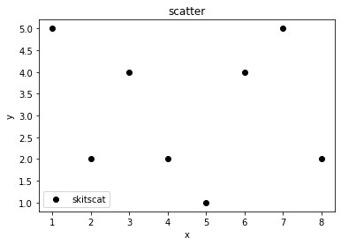

**Scatter Plot**

* import matplotlib.pyplot as

days = [1,2,3,4,5]

sleeping = [7,8,6,11,7]

eating = [2,3,4,3,2]

working = [7,8,7,2,2]

playing = [8,5,7,8,13]

plt.plot([],[],color='m', label='sleeping', linewidth=5)

plt.plot([],[],color='c', label='eating', linewidth=5)

plt.plot([],[],color='r', label='working', linewidth=5)

plt.plot([],[],color='k', label='playing', linewidth=5)

plt.stackplot(days, sleeping, eating, working, playing, colors=['m','c','r','k']

colors = ['m','c','r','k']

plt.xlabel('x')

plt.ylabel('y')

plt.title('Area plot')

plt.legend()

plt.show()

**Output:**



**Area Plot**

* import matplotlib.pyplot as plt

days = [1,2,3,4,5]

sleeping = [7,8,6,11,7]

eating = [2,3,4,3,2]

working = [7,8,7,2,2]

playing = [8,5,7,8,13]

plt.plot([],[],color='m', label='sleeping', linewidth=5)

plt.plot([],[],color='c', label='eating', linewidth=5)

plt.plot([],[],color='r', label='working', linewidth=5)

plt.plot([],[],color='k', label='playing', linewidth=5)

plt.stackplot(days, sleeping, eating, working, playing, colors=['m','c','r','k'])

colors = ['m','c','r','k']

plt.xlabel('x')

plt.ylabel('y')

plt.title('Area plot')

plt.legend()

plt.show()

**Output:**

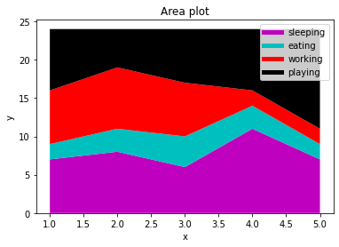

**Pie Chart**

* import matplotlib.pyplot as plt

slices = [7,2,2,13]

activities = ['sleeping','eating','working','playing']

cols = ['c','m','r','b']

plt.pie(slices,

labels=activities,

colors=cols,

startangle=90,

shadow= True,

explode=(0,0.1,0,0),

autopct='%1.1f%%')

plt.title('pie chart')

plt.show()

**Output:**

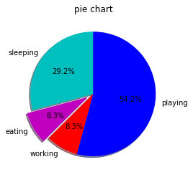

**Multiple Form Plot**

* import numpy as np

import matplotlib.pyplot as plt

def f(t):

return np.exp(-t)*np.cos(2*np.pi*t)

t1 = np.arange(0.0,5.0,0.1)

t2 = np.arange(0.0,5.0,0.02)

plt.subplot(211)

plt.plot(t1,f(t1),'bo',t2,f(t2))

plt.subplot(212)

plt.plot(t2,np.cos(2*np.pi*t2))

plt.show()

**Output:**

